**A Very Basic Guide to Remapping Controllers for Ostim and Wheeler Functionality**

**Part 1 collecting info and initial setup in game**

To use this you will need to have Steam. Also I am going to assume you have already followed the instructions on the OCM Wabba readme and have a save ready to go.

1. If you have not yet turned on turn Cobb Controlmap Fix on the left side of your MO2 list do so now. See Below.

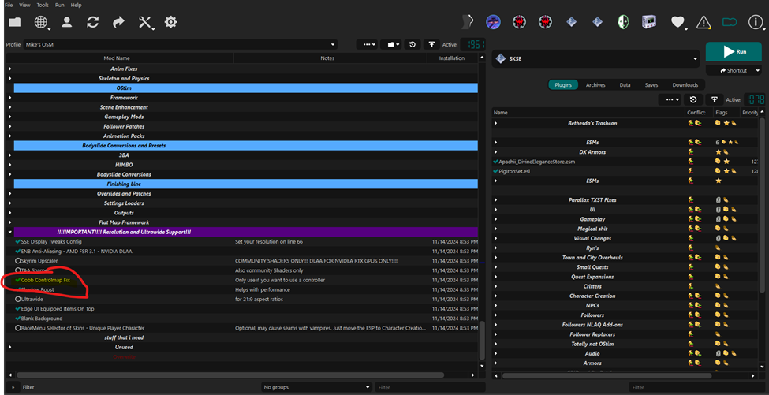

1. Fire up Skyrim and load a save. If you have a controller turned on already I would suggest going into settings and turning it off for this part so you don’t accidentally map keys to it. You are going to make note of what keys are set for what functions in OStim stand alone, which is configured in the Mod Configuration menu. Below is an example of mine. I changed the keys so yours will probably look different. If you want to remap your keys go ahead or leave them how they are and take note of them. Just be aware you do not want the controller active while you remap here because you want them to map to the keyboard right now not the controller. When finished exit the settings menu back to the regular game.

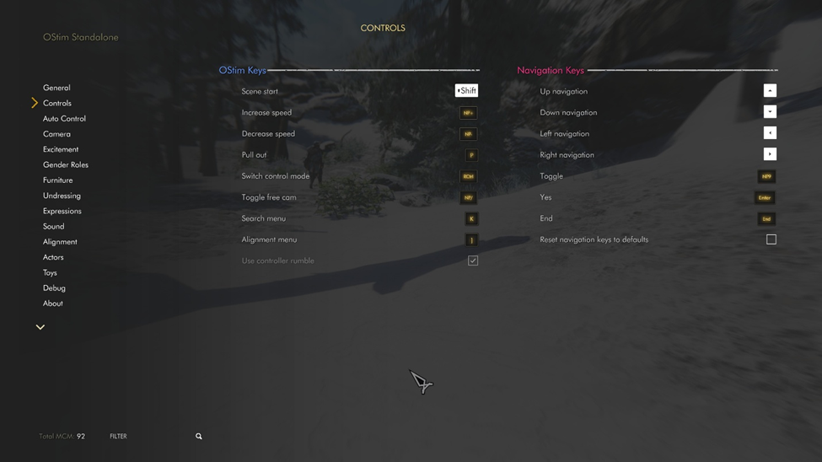

Above is OStim Menu in the Mod Configuation Menu

1. Next we will need to open dMap so we can take note of the Wheeler controls, press F10. This will open up dmap you will then need to navigate to the wheeler input bindings see below. You will need to press unbind for all the gamepad selections and write down or take a pic of the mouse/keyboard bindings. It is important to unbind the gamepad settings as we will be mapping them through steam later.

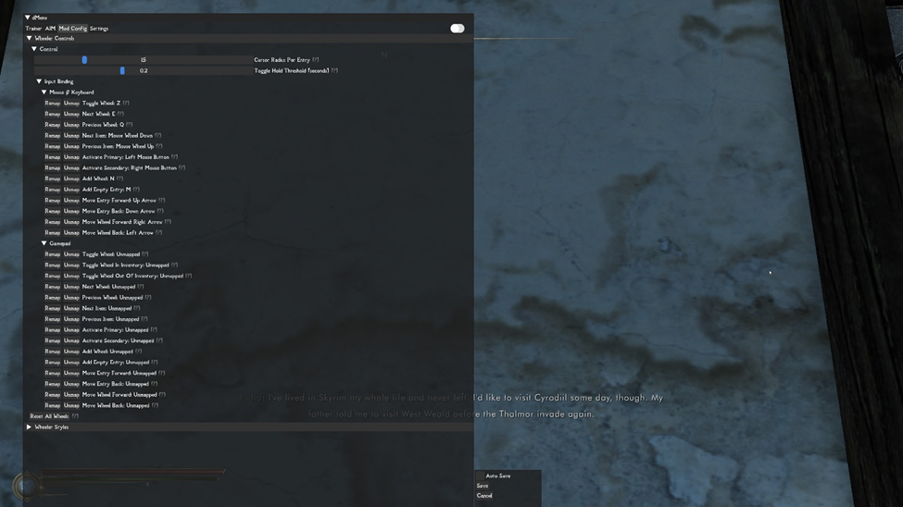

Above is the dMap configuration screen reached by pressing F10

1. After that step is complete close dMap by pressing F10. Now go into settings and turn on your controller. Make sure it works like it normally should and if it does save your game and exit Skyrim.

Next you will need to setup steam to run the OCM wabba and to use Steam overlay. See Part 2.